`

**FACULTY OF COMPUTER SCIENCE AND INFORMATION TECHNOLOGY**

**SKM3002: SEM 2 2023/2024**

**PROGRAMMING EXERCISE 1**

**LECTURER: PROF. MADYA DR. AZREEN BIN AZMAN**

| **NO.** | **NAME** | **MATRIC NUMBER** |
| --- | --- | --- |
| 1. | AIDIL ‘AQIF BIN MOHD PIDAUS | 212901 |

# Table of Content

# 

**Table of Content 1**

**1. Tools and Language Used 3**

**2. Source Code 3**

**3. Output 5**

3.1. Problem 1 5

3.2 Problem 2 7

3.3 Problem 3 7

3.4 Problem 4 8

3.5 Problem 5 8

**4.0 Github Reference 8**

# 

### 

# Tools and Language Used

These problems are being solved by using Python as the programming language and the IDE used in writing the program is Visual Studio Code (VsCode). The code is run using the extension in VsCode which is Python Debugger. The code is also uploaded to github for version control.

# Source Code

# Function to solve problem 1

def solve_problem_1():

p, q = 1, 8

return f"\n5p + 12q = ", 5*p + 12*q

# Function to solve problem 2

def solve_problem_2():

a, b, c = 2, 5, -(1/3)

return f"\n(a/4) - 6(bc - a) = ", (a/4) - 6*(b*c - a)

# Function to solve problem 3

def solve_problem_3():

x, y = 5, 7

return f"\nTotal Ashley paid (RM) = 5x + 6y = ", 5*x + 6*y

# Function to solve problem 4

def solve_problem_4():

x, y = 2, 2

return f"\nWhen x = 2, y =2 \nTotal Sally paid (RM) = ", 8*x + 22*y

# Function to solve problem 5

def solve_problem_5():

total_marbles = 1750 - 18

containers_required = total_marbles // 40 + (1 if total_marbles % 40 != 0 else 0)

return f"\nTotal Marbles = {total_marbles}.\nContainer Required = ", containers_required

# Map problem numbers to their respective functions

problems = {

1: "Given p=1 and q=8, find the value 5p + 12q.",

2: "Given a = 2, b = 5, and c = -(1/3), find the value of (a/4) - 6(bc-a).",

3: "Ashley bought x slices of vanilla-flavored cake and y slices of chocolate-flavored cake.\nIf the cost of one slice of vanilla-flavored cake and a slice of chocolate-flavored cake is RM5 and RM6, respectively,\nexpress the amount to be paid by Ashley in terms of x and y. State the result when x=5 and y=7.",

4: "In a market, Miss Sally bought x kg of chicken at RM 8 per kg and y kg of beef at RM22 per kg. Show the result when x=2 and y=2.",

5: "On a particular day, a machine produced 1750 marbles, 18 of which were substandard.\nAfter removing all the substandard marbles, the remaining marbles are packed into x containers, each with a capacity of 40 marbles.\nCalculate the minimum number of containers required to pack the remaining marbles."

}

# Function to display the list of available problems

def display_problems():

print("\n_________________________________________________________________________________________________________________________________________________________________________________________________\n")

print("\nAvailable problems:\n")

for num, desc in problems.items():

print(f"Question {num}:\n{desc}\n")

print("\n_________________________________________________________________________________________________________________________________________________________________________________________________\n")

# Main program

while problems:

display_problems()

choice = input("\nEnter the number of the problem you want to solve (1-5), or enter 'q' to quit: ")

if choice.lower() == 'q':

print("Thank you for using this program!")

break

try:

problem_num = int(choice)

if problem_num in problems:

if problem_num == 1:

explanation, result = solve_problem_1()

elif problem_num == 2:

explanation, result = solve_problem_2()

elif problem_num == 3:

explanation, result = solve_problem_3()

elif problem_num == 4:

explanation, result = solve_problem_4()

elif problem_num == 5:

explanation, result = solve_problem_5()

print("Result:", explanation, result)

del problems[problem_num]

else:

print("Question has been solved." if problem_num not in range(1, 6) else "Invalid choice. Please try again.")

except ValueError:

print("Invalid choice. Please enter a number (1-5) or 'q' to quit.")

# Output

## 3.1. Problem 1

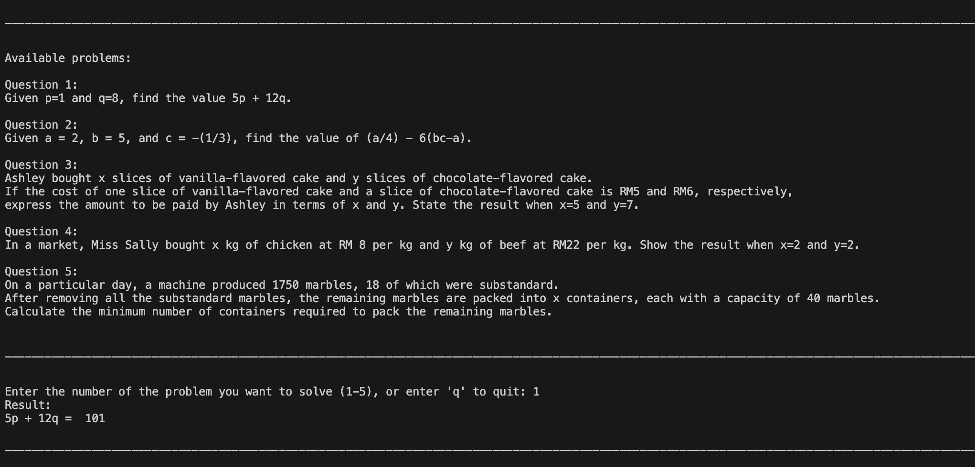

## 3.2 Problem 2

## 

## 3.3 Problem 3

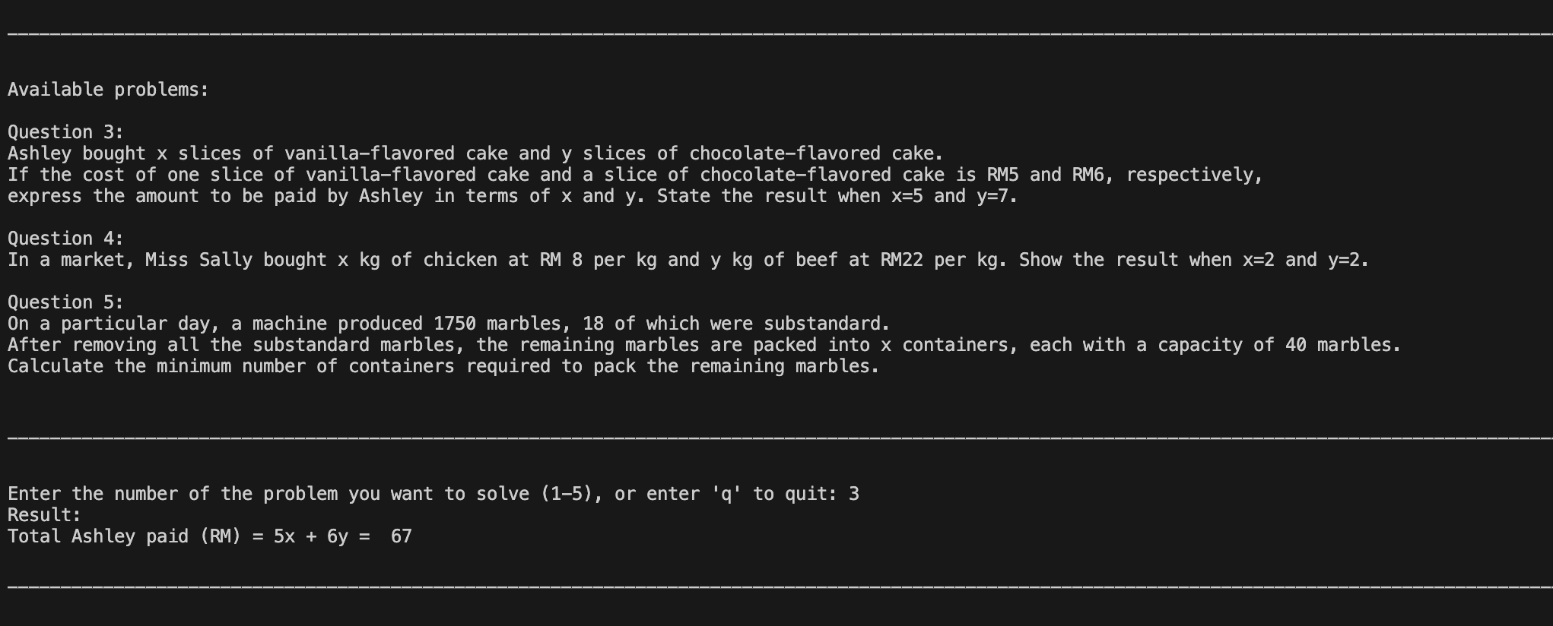

## 3.4 Problem 4

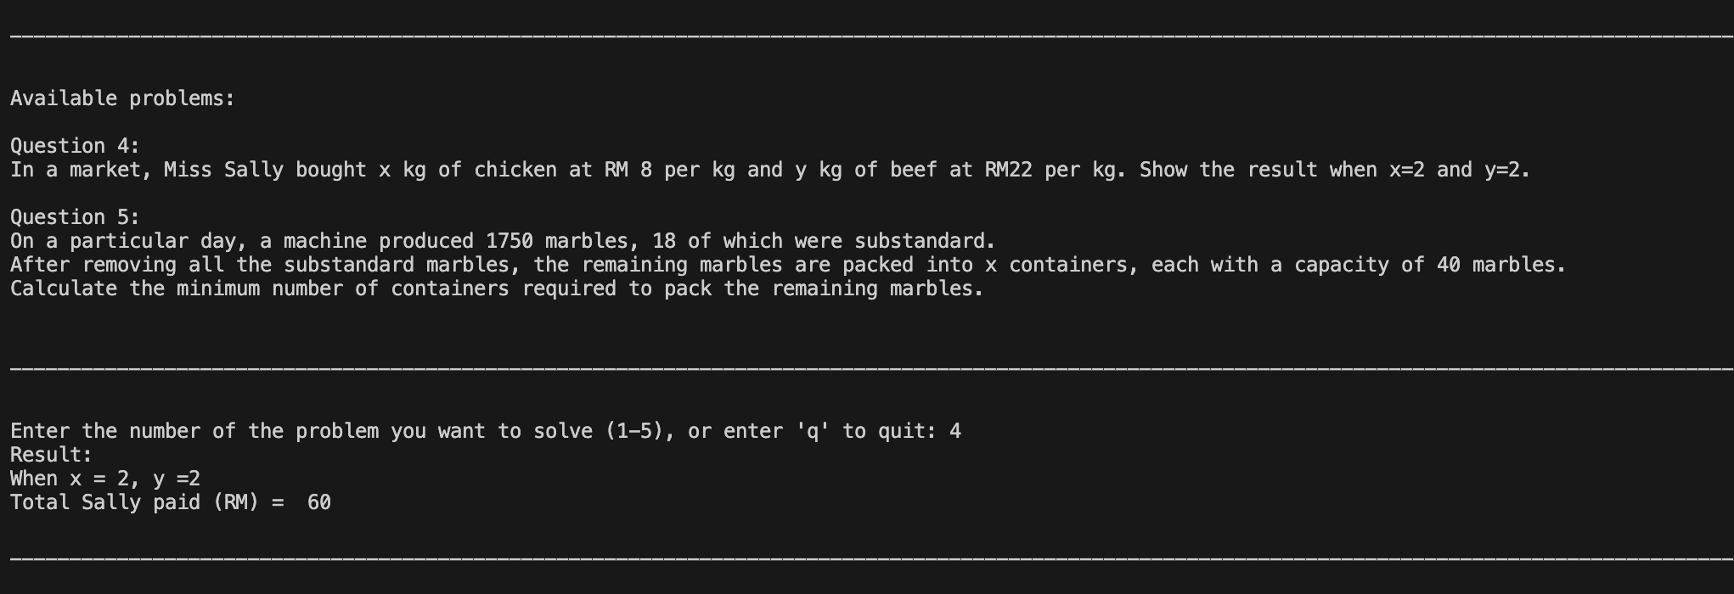

## 3.5 Problem 5

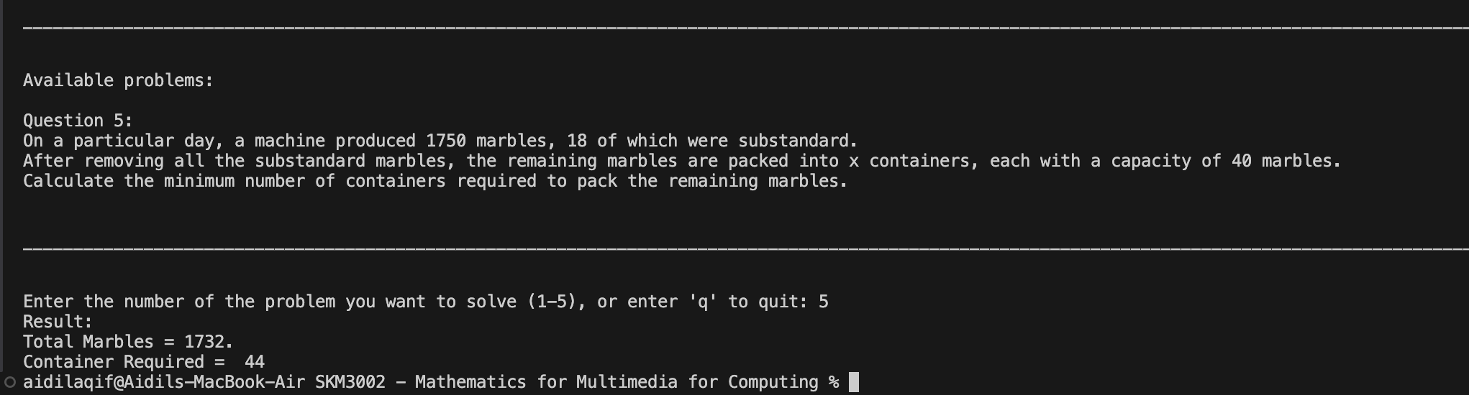

# 4.0 Github Reference

<https://github.com/aidilaqif/SKM3002---Mathematics-for-Multimedia-for-Computing/tree/main/src%20code/Exercise%201>